Registering for Application Support Training Classes

Go to Edutech’s home page - www.edutech.org

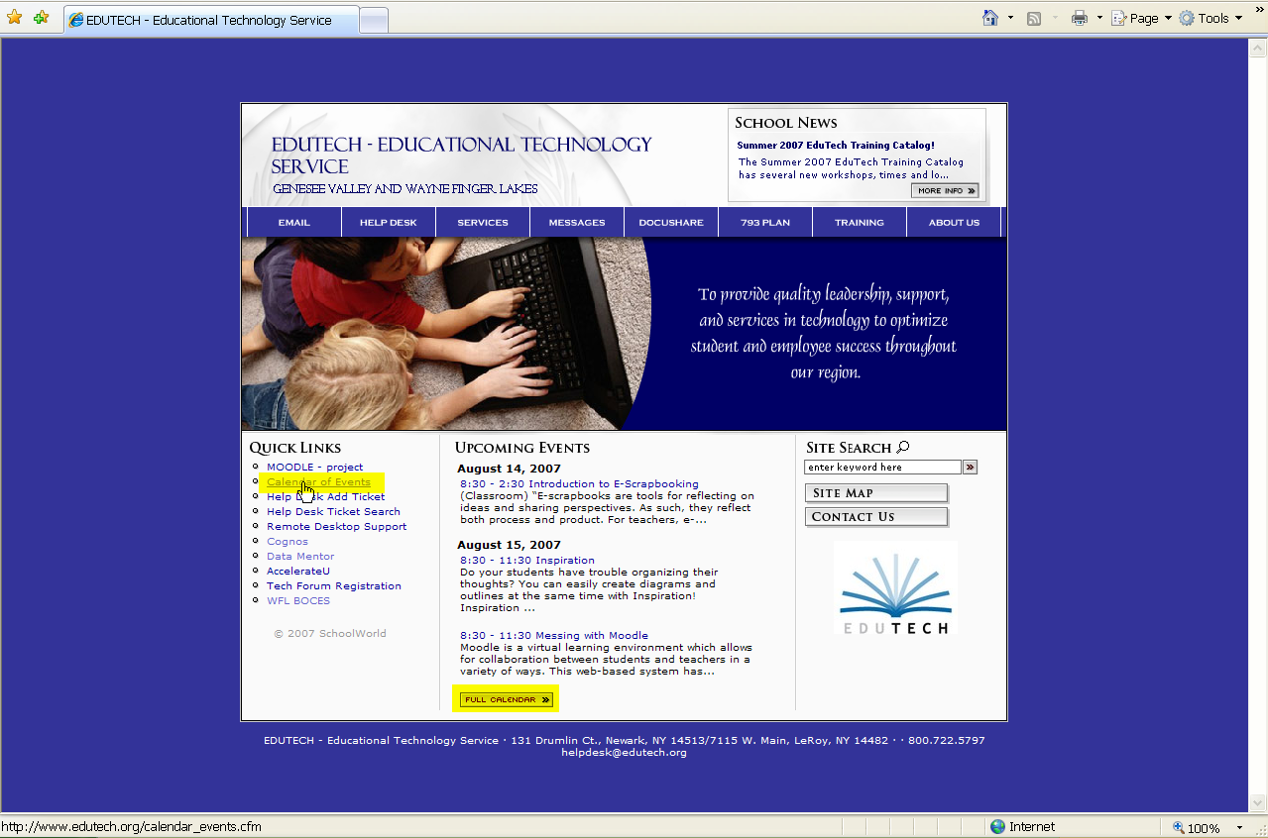

Click on Calendar of Events under Quick Links or scroll down to select Full Calendar - both show the same information.

Once the calendar comes up, you can click on Customize Calendar which is in the upper right, above the calendar. This feature allows you to define your selection.

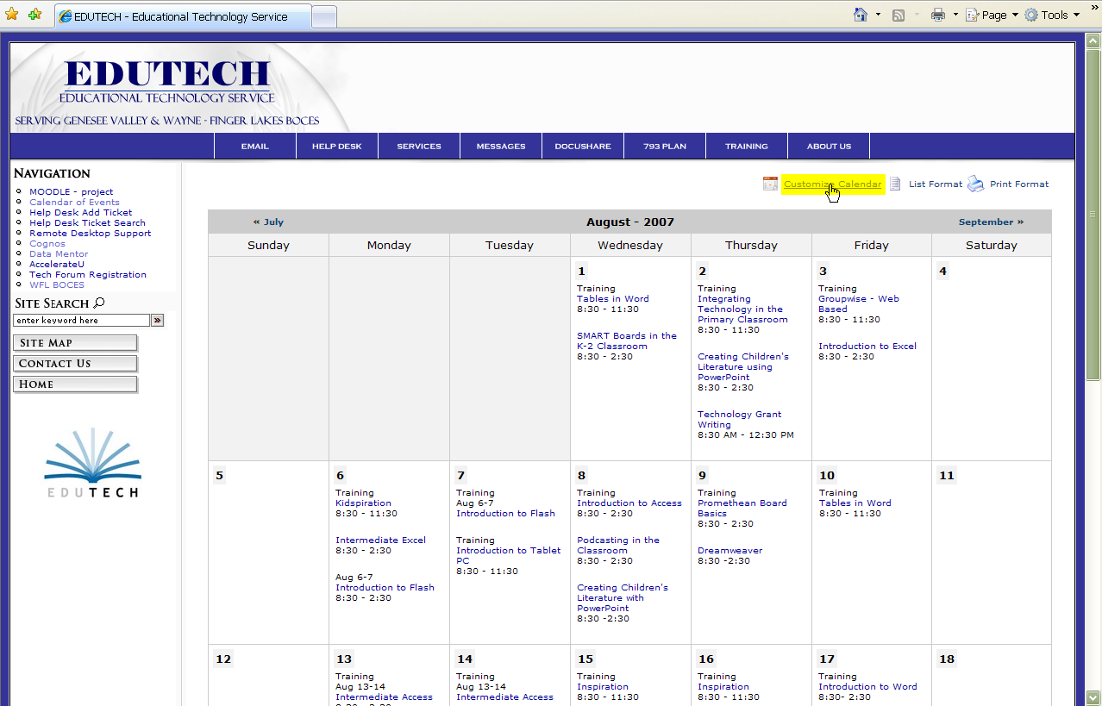

Check desired application(s), then click on Update Calendar.

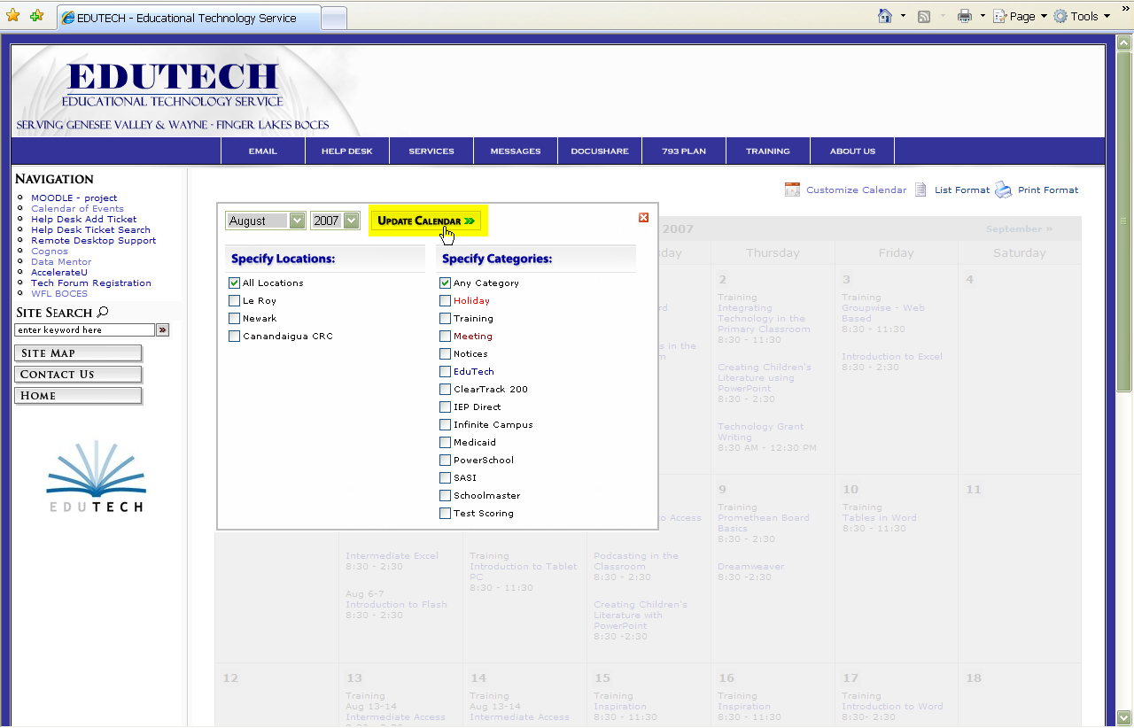

Your Calendar will show just the classes for the application(s) that you selected.

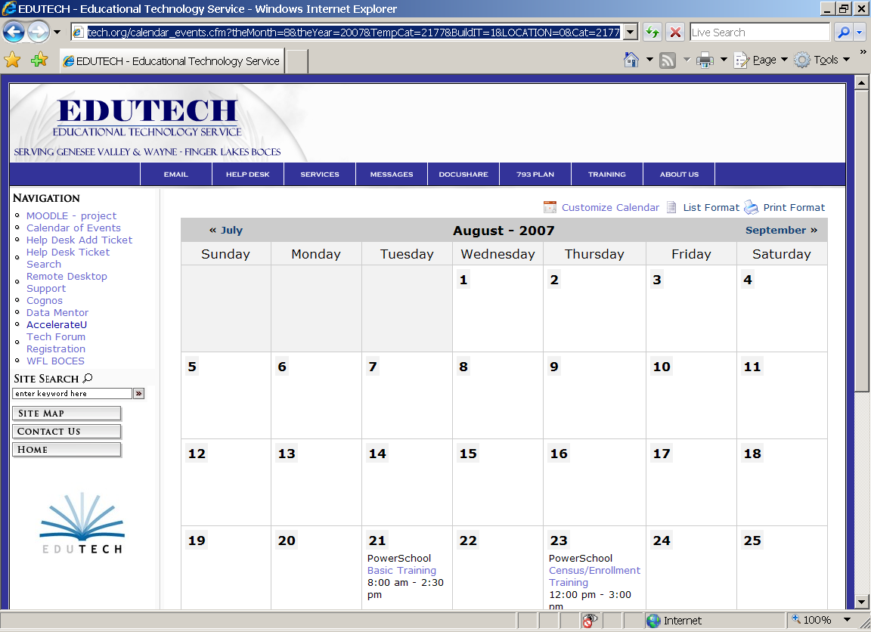

Click on the class that you would like to attend – a pop up window will appear. If you would like an email reminder sent to you – click on Remind Me and enlarge the screen. Enter your email address and date(s) that you would like to receive a reminder email. Click on submit form and then click on back to event.

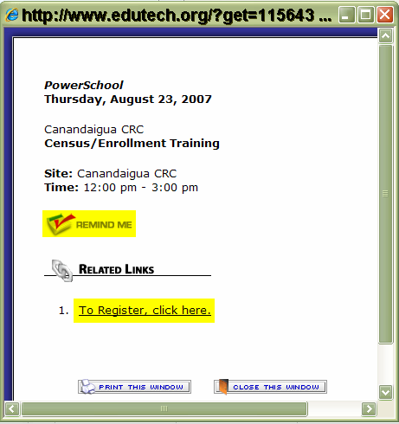

Now click on the To Register link, which will bring you to the login area.

Login using your first and last name and a password of edutech123.

You are logging into the Student Application Development area.
First Name
Last Name
Password
forgot password?

Create a new password on this screen.

Login Screen
john jones
Welcome to EduTech.
You are about to create a new login account.
Please enter a new password.
Password
If you already have an account,
please go back and re-enter your name and password.
go back to login
If you are not in the system, the following screen will need to be completed. For now, please enter your school telephone # under the home address section.
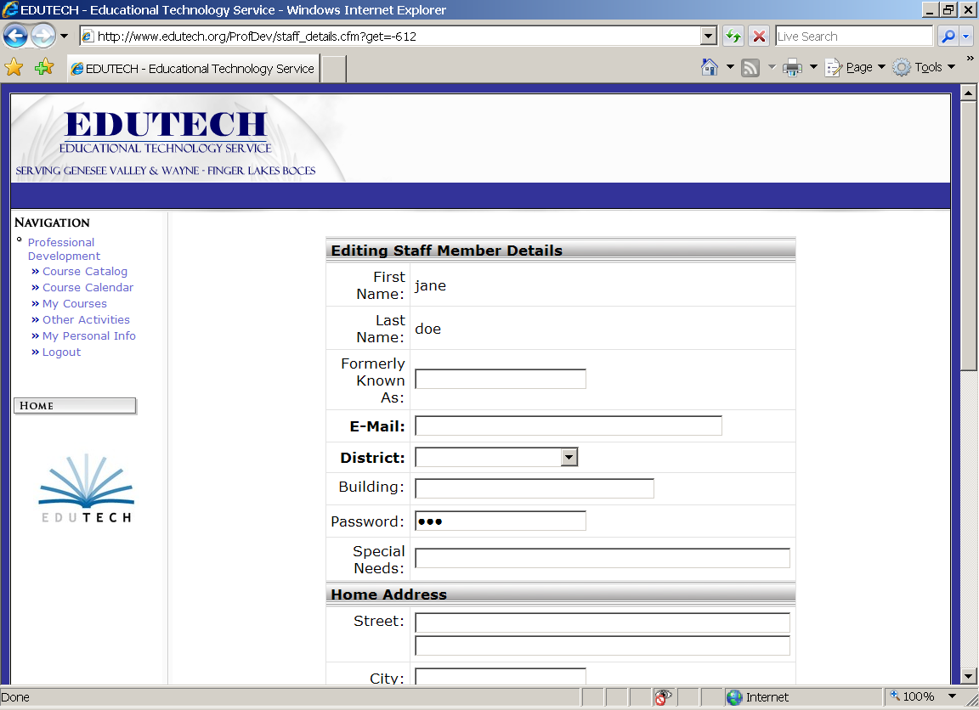
When done, scroll to the bottom and click on the Save button.

Now Select Course Catalog or Course Calendar.

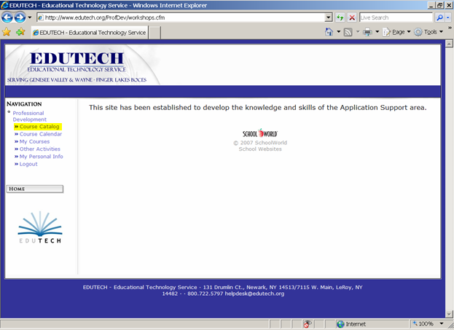

Course Catalog: Click on a category name.

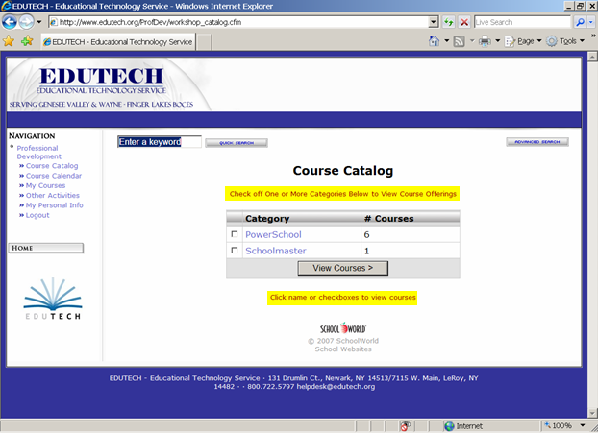

Course Catalog:

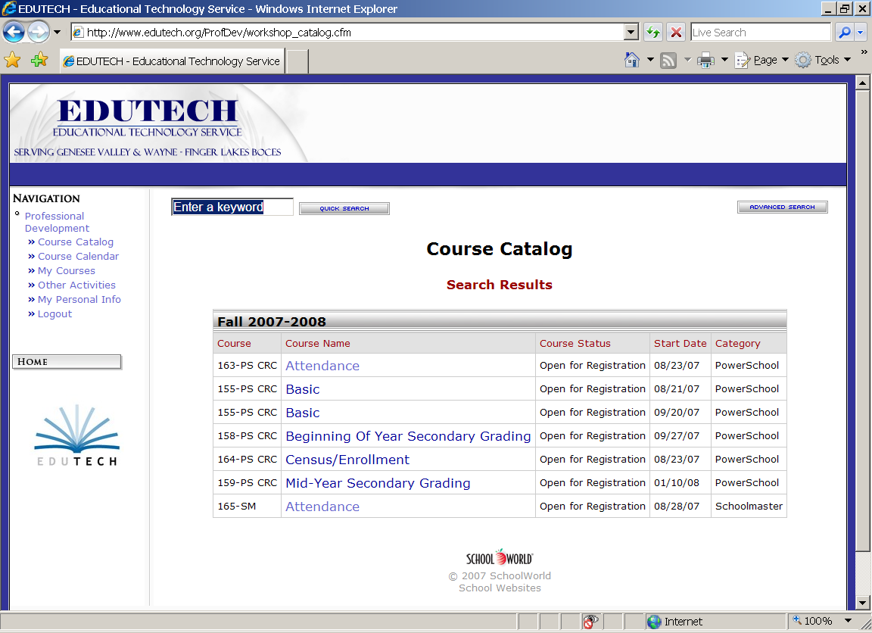

Click on Course Name.

Course details screen will be shown – scroll down to the Register For Course button and click.

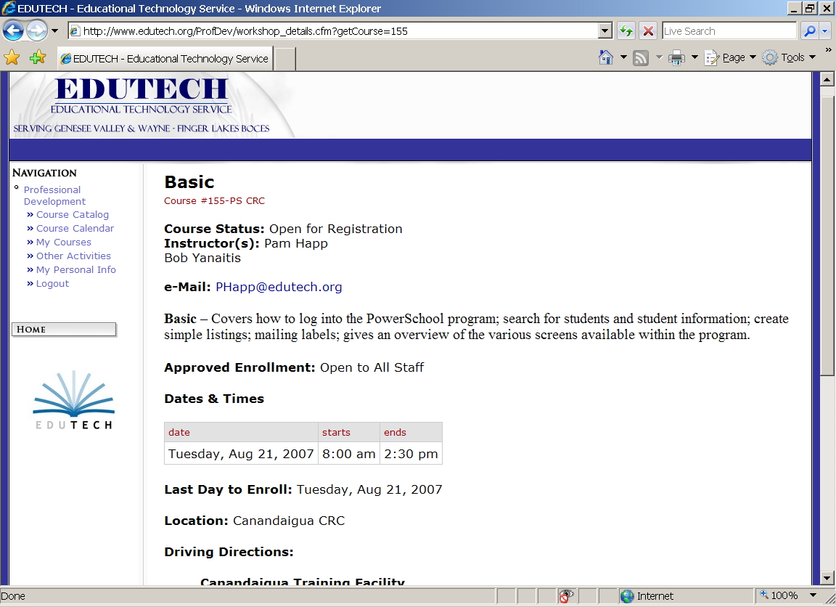

Click on the Add Registration Button. You will receive an email confirming your registration.

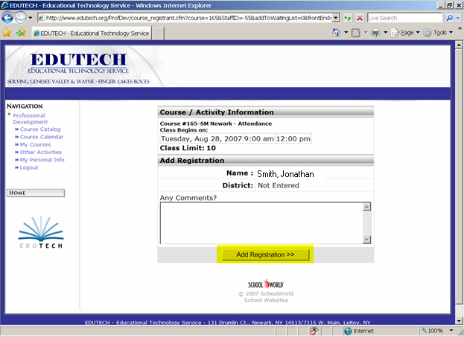

Or to use the Course Calendar link:

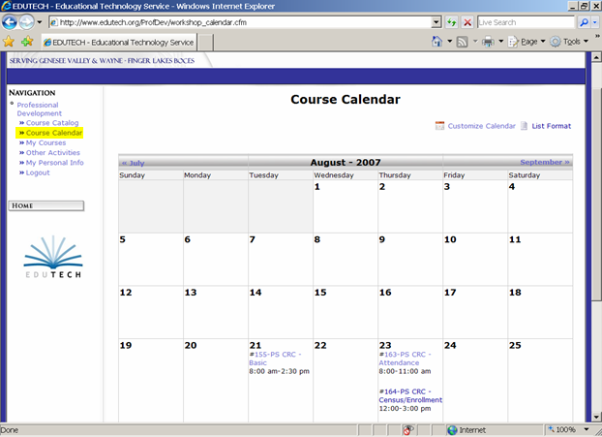

Click on the desired class.

The Course details screen will be shown. Scroll down to the Register For Course button and click.

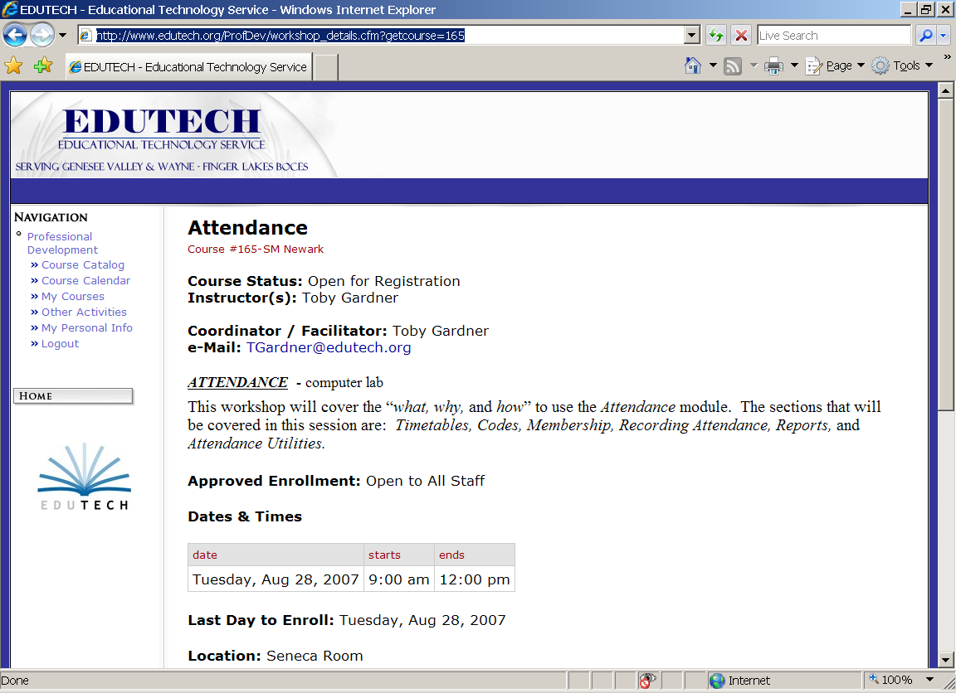

Click on the Add Registration Button. You will receive an email confirming your registration.

